

**Parkify**

**MIN HAN TAN**

G00377221

**BEng(H) in Software & Electronic Engineering**

**Project Engineering**

Supervisor: Paul Lennon

Galway-Mayo Institute of Technology

2022/2023

# Project Description

Thousands of companies, both in the public and private sectors, strive hard every day to enhance the quality and functionality of their on-site parking facilities. Hence, smart parking has a simple, straightforward, cost effective, and reliable solution that can be tailored to the sites and the company’s needs. I will be creating a smart parking system which uses ALPR (Automatic License Plate Recognition) technology that reads and stores vehicle registration plates to calculate the parking rates for the customers.

*Parkify* is a smart parking system which uses ALPR technology that will make more convenient for the customers and companies that manage car park. The ALPR technology requires machine learning that uses the power of AI and deep learning to automatically detect and recognize the characters of as vehicle’s license plate. In addition, TensorFlow is the library I will be using for training my machine learning model with the YOLO (You Only Look Once) Object Detection system.

*Parkify* smart parking system is operated from a Raspberry Pi with camera module and implement with the machine learning model to detect and read the license plate of the car. The license plate of the car will save to the SQL database hosted on Amazon Web Services. Besides that, SQL Server will retrieve the entry and exit time of the users then pass it to Raspberry Pi which programmed to calculate the parking fee of the user. In addition, a servo motor will control the prop that raises and lowers the parking barrier. The software programming languages I will be using are Python, Embedded C and MySQL for the database.

On the other hand, the challenge in this *Parkify* will be machine learning and setting up the AWS as the backend database for the project as I have not learnt and done that previously.

# Architecture Diagram

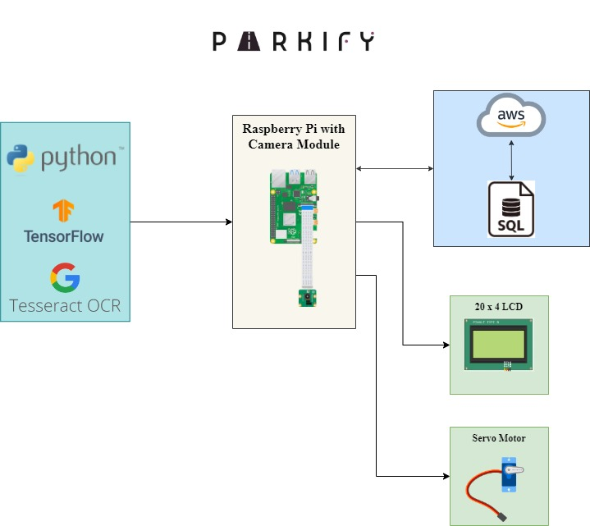

Languages to be Used

The languages I will use in this project are the following:

|  |  |  |
| --- | --- | --- |
| Embedded C | Python | MySQL |

Hardware Requirements

|  |  |
| --- | --- |
| Raspberry Pi 4 | 20 x 4 lcd screen |
| Camera Module for Raspberry Pi | Servo Motor |

# Timeline for deliverables

